FIT5196 Assessment 1 Group005 EDA report
Customer spending, review representation and delivery performance

Report scope | Content
Data | 5,000 orders; 15,739 item lines; 500 customers; 1,000 products; 5,000 deliveries; 7,000 reviews
Assessed figures | Figures 1-8
Assessed findings | Exactly 10 numbered evidence-based findings
Future ML questions | Exactly 5 numbered questions
Page-limit treatment | 10 assessed pages (PDF pages 3-12); cover, contents and references outside that section

Prepared from Group005_EDA_submitted.ipynb. Figures reproduce its saved outputs; the notebook and solution artifacts contain the complete executable record.

Contents

Section | PDF page
Context and data-preparation assurance | 3
Figures 1-2: transaction structure | 4
Figures 3-4: portfolio and review representation | 5
Figures 5-6: review experience and calendar activity | 6
Figures 7-8: delivery operations | 7
Findings 1-5 | 8
Findings 6-10 | 9
ML questions 1-3 | 10
ML questions 4-5 | 11
Limitations | 12
References and reproducibility | 13
The assessed report occupies pages 3-12. Code, full supporting tables and supplementary audits remain available in the submitted notebook. Figure categories, observation units and joins are stated with each visualisation.

Context and data-preparation assurance
Business context and scope: This EDA examines a Melbourne technology retailer's 2018 transactions, combining CommercePlatform JSON and OperationsERP XML exports. The six standardised tables contain 5,000 orders, 15,739 item lines, 500 customers, 1,000 products, 5,000 deliveries and 7,000 reviews. Analysis distinguishes order, item, customer, product, delivery and review grain in which delivery assessment covers completed orders and review timestamps may extend beyond the 2018 order period.

Five material transformation decisions

Decision and stable mapping references | Why it matters for this EDA
Reconcile by business key after normalisation. Coalesce agreeing JSON/XML values into one canonical record; log differing non-missing values rather than impose source priority. Preserve order and item identities (MAP-orders-01,  MAP-order_items-01; solution T2-R1). | Prevents repeated exports from inflating order counts, sales and review coverage.
Standardise structured values without losing missingness. Parse order timestamps, normalise currency/discount representations and retain literal NaN for absent coupon codes (MAP-orders-04, MAP-orders-07, MAP-orders-12,  MAP-orders-13). | Makes calendar exposure and monetary comparisons consistent; preserves missing-code meaning.
Build monetary totals from canonical item lines. Round quantity × unit price to cents, sum lines for gross order value, calculate included GST as gross/11, then apply the percentage discount and add delivery; do not add GST again  (MAP-order_items-06, MAP-orders-10, MAP-orders-14, MAP-orders-15). | Separates gross merchandise value from customer-paid value and prevents duplicate items or tax double-counting from distorting F1–F3.
Keep extraction and text representations distinct. Extract references from parser-obtained raw text before cleaning; preserve multilingual cleaned text, derive a separate  Latin-analysis field, and calculate text measures with sentinel-aware rules (MAP-product_reviews-10, MAP-product_reviews-11,  MAP-product_reviews-14–MAP-product_reviews-18). | Protects reference linkage, multilingual representation and sentinel-aware text measures.
Retain the delivery eligibility boundary. Keep canonical deliveries linked to completed orders (MAP-orders-09, MAP-deliveries-02; solution T2-B3). | Defines the denominator for F7–F8; delivery performance cannot describe cancellations, lost sales or orders outside this eligible population.

Six material validation results
Evidence: saved PASS results in Group005_solution.ipynb; mapping IDs follow its successful T1-M1 audit. The full pipeline was not rerun for this summary.

Validation evidence / stable IDs | Observed result and analytical consequence
Entity and relationship integrity: VAL-PK-orders, VAL-PK-order_items, VAL-FK-order_items-order_id,  VAL-FK-product_reviews-order_item_id (representative checks from the six PK/eight FK checks). | All six primary keys are complete and unique; all eight required FK checks report zero missing or unmatched keys. Parent linkage is valid; join cardinality remains a separate check.
Source reconciliation: VAL-FLOW-orders, VAL-FLOW-order_items, VAL-CONFLICT-01. | Orders: 2,750 JSON keys + 2,750 XML keys − 500 shared = 5,000.  Items: 8,723 + 8,618 − 1,602 = 15,739. Zero field conflicts after normalisation; observed source keys survive without duplicate counting.
Monetary reconstruction: VAL-ARITH-01–VAL-ARITH-05. | Line, gross-order, included-tax and paid-total checks report zero maximum absolute difference at AUD 0.01 tolerance; all 5,000 orders reconcile, and none matches the incorrect tax-added-again formula. Monetary identities pass; cost completeness is untested.
Chronology: VAL-TIME-order-dispatch,  VAL-TIME-dispatch-promised, VAL-TIME-dispatch-delivered, VAL-TIME-delivery-review. | Zero violations across the 5,000 delivery comparisons and 7,000 review comparisons. Valid chronology does not establish equal review follow-up.
Review measurement and linkage: VAL-TEXT-review-sku, VAL-TEXT-review-order, VAL-TEXT-review-measures,  VAL-TEXT-multilingual. | References agree for 7,000 reviews, and derived length/word measures pass. 276 cleaned reviews retain non-Latin script, with 276 matching flags and zero non-Latin residue in the separate Latin output. Measurement checks do not validate text semantics.
Missing-code contract: VAL-SENTINEL-coupon_code, VAL-SENTINEL-promo_code. | Each field contains 3,133 literal NaN values, with zero blanks or malformed codes. Absence remains explicit rather than becoming an apparent promotion.
Boundary: valid preparation does not establish causality, representative reviews or full cost coverage. The EDA separately audits join cardinality and aggregates items before attaching order totals to prevent multiplication.

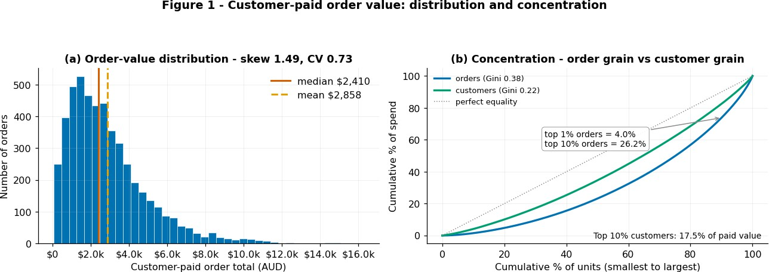
Question: How variable is paid order value, and how concentrated is spending?
Observation unit and denominator: one order; n = 5,000. A companion panel uses customer grain (n = 500) for the correct resilience denominator.
Tables and join keys: orders only (no join); the customer panel aggregates orders by customer_id.
Evidence and interpretation: Mean paid value is AUD 2,858 versus median AUD 2,410. The top 10% of orders contribute 26.2% of paid value, versus 17.5% for the top 10% of customers; Gini is 0.38 versus 0.22. Histogram and Lorenz curves reveal skew and concentration at the appropriate grains. Limitation: a single year does not establish persistence or future resilience; paid totals include coupons, delivery and GST and are not profit.
Figure 2: Quantity × weighted price and gross value (multivariate)
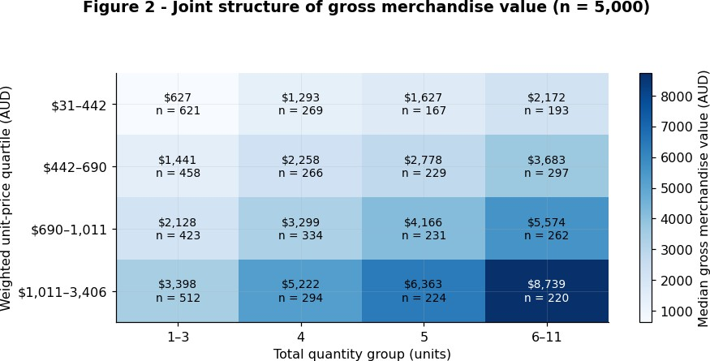
Question: How do quantity and weighted unit price jointly structure gross merchandise value?
Observation unit and denominator: one order, n = 5,000; each heatmap cell reports the median and its order count.
Tables and join keys: order_items aggregated to order grain, then joined to orders on order_id (one-to-one).
Evidence and interpretation: Cell medians compare quantity and weighted-price groups while counts show support. Median gross value ranges from AUD 627 to AUD 8,739 between opposite corners. Additive log-variance shares are 57.0% weighted price, 32.1% quantity and 10.9% twice the covariance. Limitation: gross value equals quantity times weighted price by definition. These are algebraic shares, not predictive importance or causal effects; gross value excludes discounts and delivery.

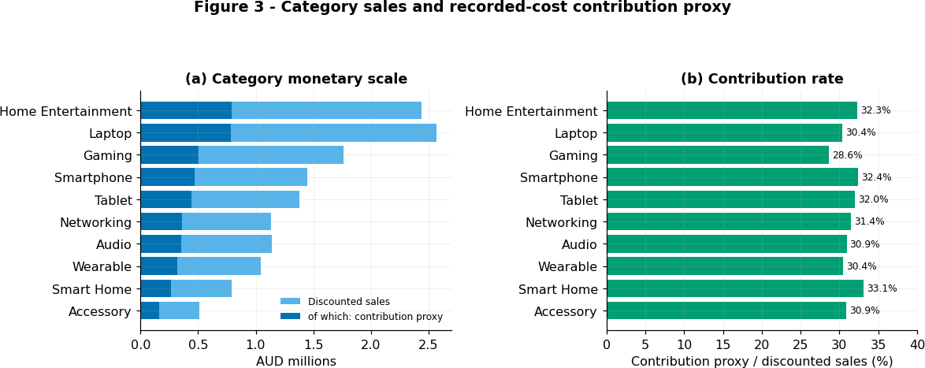
Question: Which categories account for merchandise value and recorded contribution?
Observation unit and denominator: item lines aggregated by category; rates divide the category contribution proxy by discounted category sales.
Tables and join keys: order_items joins products on product_id, then orders on order_id (both many-to-one).
Evidence and interpretation: Comparing sales scale and contribution rates separates category size from recorded margin. Discounted sales span about fivefold, from AUD 512k (Accessory) to AUD 2.57M (Laptop), while contribution rates span 28.6%-33.1%. Limitation: allocated discounts and recorded unit costs are proxies; tax treatment and overhead coverage must be checked before treating contribution as profit or recommending investment.

Figure 4: Coverage within line-count strata and by item price (multivariate/review)
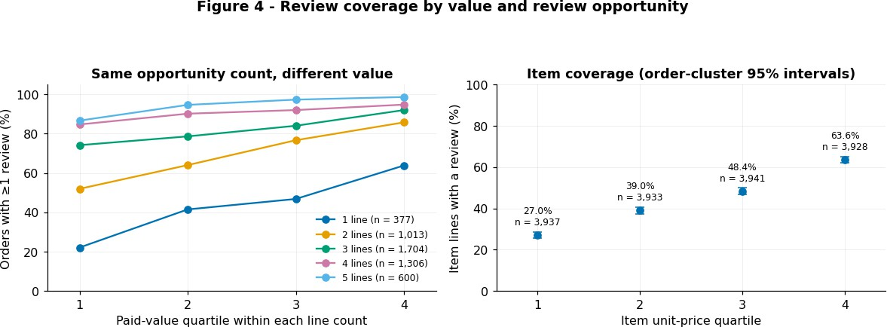
Question: Does review coverage increase with value within equal item-line counts?
Observation unit and denominator: Panel A: orders within exact line-count strata and within-stratum paid-value quartiles. Panel B: item lines by unit-price quartile; numerators are item lines with ≥1 review.
Tables and join keys: Order-item counts → orders on order_id; review presence via order_id / order_item_id; category from products on product_id (many-to-one). Order counts are aggregated before a one-to-one order join; membership flags cannot multiply rows.
Evidence and interpretation: Stratified coverage comparisons address basket opportunity and item price. Within 1,704 three-line orders, coverage rises from 74.2% to 92.0% across value quartiles. Item coverage rises from 27.0% to 63.6% across price quartiles; the direction persists within all ten categories. Limitation: these are separate composition checks, not joint adjustment. Customer differences and unverified follow-up completeness remain possible explanations.

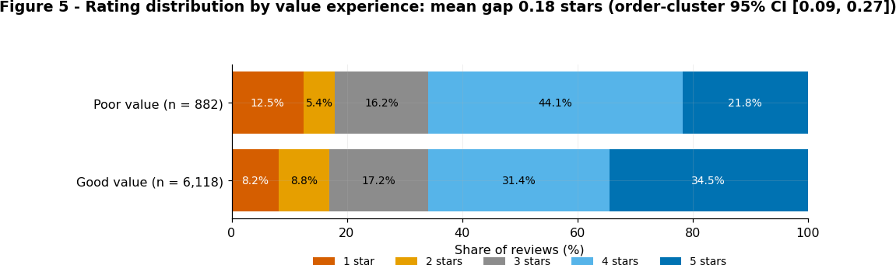
Question: How does the full rating distribution differ between reported good and poor value?
Observation unit and denominator: Reviews, clustered within orders; each review receives equal weight.
Tables and join keys: product_reviews for the rating distribution, with order_id defining the bootstrap clusters. The two marginal statistics add one audited many-to-one join each on order_id: product_reviews → orders for order_total, and product_reviews → deliveries for on_time_in_full. Both parents are unique on order_id, so neither join can multiply review rows (7,000 in, 7,000 out, 0 unmatched, reported by join_audit).
Evidence and interpretation: The full ordinal distribution reveals what a binary favourable-rating summary hides: at least four-star shares are 65.85% and 65.87%, but five-star shares differ by 12.7 percentage points. The mean gap is 0.179 stars (95% order-cluster bootstrap CI
0.092-0.267); Cliff's delta is 0.093. Limitation: value experience and rating are co-reported, reviewed purchases are selective, and order clustering does not address repeated-customer dependence.

Figure 6 - Calendar-exposure-normalised activity (temporal)
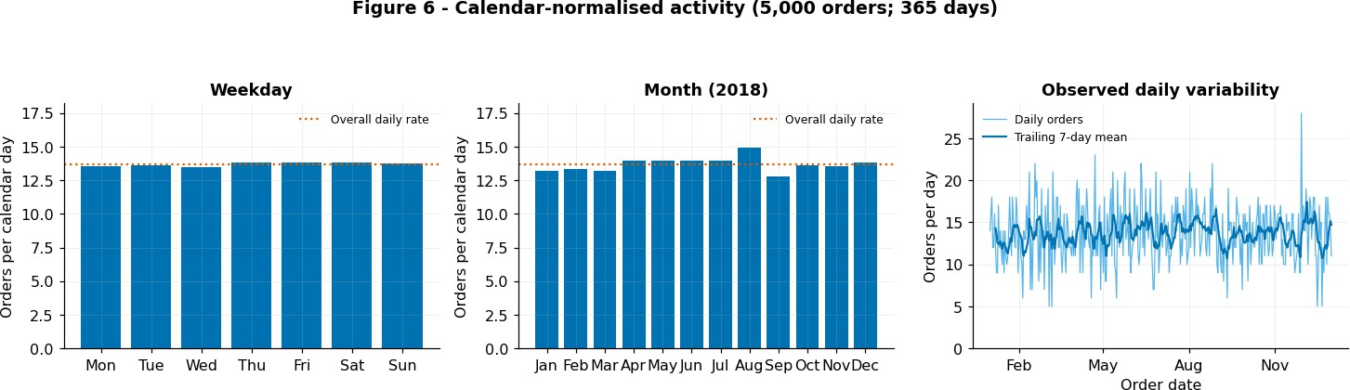
Question: How much do weekday and monthly order rates vary after calendar exposure?
Observation unit and denominator: Orders per calendar day in each weekday/month; zero-order dates included.
Tables and join keys: orders.order_timestamp; no join.
Evidence and interpretation: Normalising by calendar-day exposure makes weekday and month comparisons comparable. Weekday rates span 13.50-13.85 orders/day and monthly rates 12.80-14.94; daily SD is 3.55 and IQR is 5. Limitation: near-flat averages do not establish predictability. One year cannot identify recurring seasonality, and calendar days do not measure marketing or opening-hour exposure.

Figure 7 - Recorded warehouse, service and OTIF (delivery/operational performance)
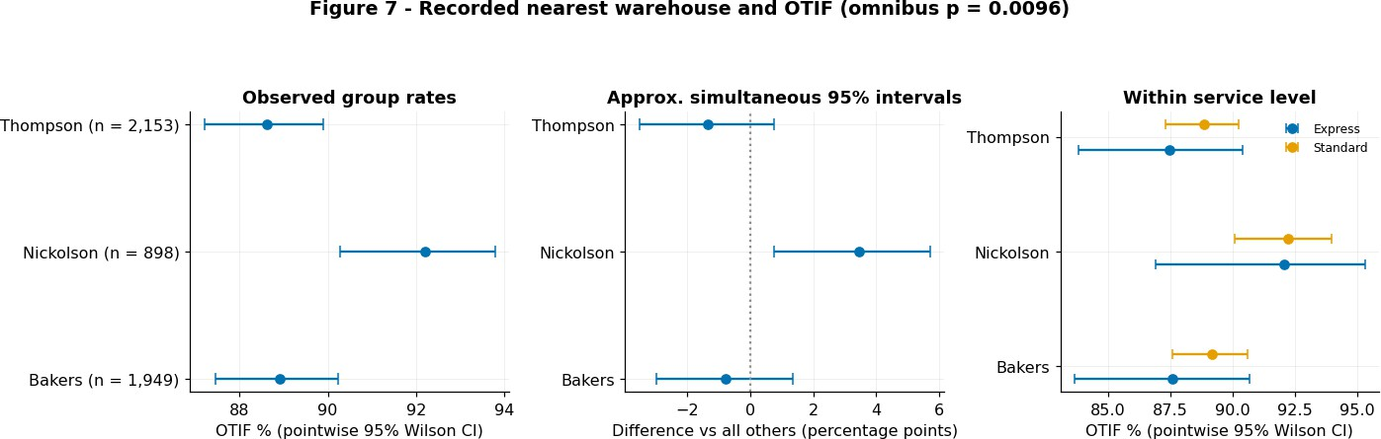
Question: Do OTIF rates differ across the recorded nearest-warehouse groups? Observation unit and denominator: Deliveries; group successes / group deliveries. Tables and join keys: deliveries joins orders on order_id (one-to-one).
Evidence and interpretation: Rate comparisons with uncertainty intervals expose support and precision. Nickolson records 92.2% OTIF (898 deliveries), versus 88.8% elsewhere (4,102), a 3.44-point gap with approximate simultaneous 95% CI [0.77, 5.70]. The advantage persists within both services. Limitation: service adjustment does not remove geography or other case mix; nearest warehouse is not verified dispatch origin, and repeated customers can affect uncertainty.

Figure 8 - Delivery cost recovery by service (delivery/operational performance)
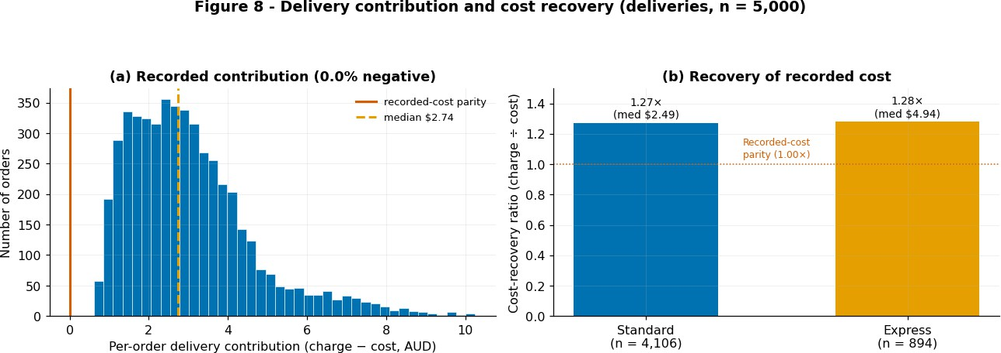
Question: How do charges compare with recorded delivery costs across services?
Observation unit and denominator: deliveries; recovery = sum(charges) / sum(recorded costs), not the average of individual order ratios.
Tables and join keys: deliveries → orders on order_id (one-to-one).
Evidence and interpretation: Comparing charges, recorded costs and recovery ratios separates monetary scale from relative recovery. All 5,000 matched deliveries have non-negative recorded contribution; the aggregate difference is AUD 15,095 and median AUD 2.74. Standard and Express recovery ratios are 1.27 and 1.28. Limitation: recorded cost coverage is incomplete; positive recovery does not establish full profitability or delivery reliability.

Finding 1: Large transactions do not establish dependence on a small customer elite.
  - Across 5,000 orders (500 customers), mean paid order value exceeds the median ($2,858 versus $2,410), but concentration falls at customer grain: the top 10% of orders contribute 26.2% of paid value, whereas the top 10% of customers contribute 17.5%, and the Gini falls from 0.38 (order grain) to 0.22 (customer grain). Transaction variability should therefore not be translated directly into a VIP-focused retention strategy. The unresolved question is whether high customer spending persists across periods or reflects occasional large baskets. Evidence: Figure 1. → MLQ-1

Finding 2: Weighted price is the larger structural share of basket-value dispersion, but the accounting identity is not a predictive discovery.
  - At order grain (n = 5,000), quantity-weighted unit price contributes 57.0% of the log gross-value variance, versus quantity's 32.1% and twice their covariance 10.9% (additive algebraic shares of an identity, not importance weights). This supports examining what customers buy alongside how much they buy. However, weighted price is itself gross value divided by quantity, so predicting the same basket's gross value from these components would largely reconstruct an identity; a meaningful modelling task must instead predict future purchasing behaviour from information available beforehand. Evidence: Figures 1–2 and the monetary safeguards. → MLQ-1

Finding 3: Commercial importance depends on sales scale and contribution rate jointly; neither ranking alone identifies an investment opportunity.
  - Across 15,739 item lines in ten categories, discounted sales span about 5.0× ($512k for Accessory to $2.57M for Laptop), while contribution-proxy rates range only 28.6%–33.1%. The much wider sales variation makes scale central to absolute contribution, although rate differences can still reorder similarly sized categories. Consequently a high-rate category is not automatically the largest contributor, and a large contributor is not automatically the best growth opportunity. Demand persistence and comparable costs must be established before translating portfolio rankings into investment priorities. Evidence: Figures 2–3. → MLQ-1

Finding 4: Broad order-level feedback coverage conceals substantial gaps in product-level representation.
  - At least one review appears on 4,017 of 5,000 orders (80.3%), yet only 7,000 of 15,739 item lines (44.5%) are reviewed. These denominators answer different questions: an order can look represented while most of its purchased items remain unobserved, so order-level engagement is an inadequate assurance of product-feedback completeness. These are also export-observed coverage rates, not verified eventual response rates - the data contain orders through 2018-12-31, deliveries through
2019-01-10 and reviews through 2019-02-20, so the latest review is ~41 days after the latest delivery. Potential observation time and follow-up completeness must be established from the extraction contract before reading these as final response rates or defining mature 30-day cohorts; the observed price-coverage gradient does not depend on that verification. Review monitoring should assess item coverage explicitly, on a matured window, with separate checks across price and category. Evidence: Figure 4A–B. → MLQ-2

Finding 5: Value-related review selection survives two separate composition checks, making representation a central analytical concern.
  - Within the 1,704 three-line orders (426 per within-stratum value quartile), review coverage rises from 74.2% to 92.0% across paid-value quartiles. At item grain, across all 15,739 item lines (about 3,935 per unit-price quartile), coverage rises from 27.0% to 63.6%, and higher-priced item lines have greater coverage within all ten categories (10 of 10 on a within-category median split). These are two separate checks - holding line count fixed and splitting within category - not a single jointly adjusted control, and together they weaken basket opportunity count and category composition as sole explanations.
Higher-priced purchases are overrepresented in review data, but this does not establish that ratings are biased upward or downward; customer differences and unequal follow-up remain unresolved. Evidence: Figure 4 and its supporting tables. → MLQ-2

Finding 6: Binary satisfaction conceals a small but statistically detectable ordinal shift alongside a sizeable five-star-share difference.
  - Across all 7,000 reviews, the 6,118 good-value and 882 poor-value reviews have virtually identical ≥4-star shares (65.85% versus 65.87%), but their five-star shares differ by 12.7 percentage points (34.5% versus 21.8%). The mean gap is 0.179 stars (order-cluster 95% CI [0.092, 0.267]) with Cliff's δ = 0.093 - a small overall ordinal separation despite the sizeable
top-category difference. A binary favourable-rating metric therefore hides movement within favourable feedback; full ordinal outcomes are more informative, while the modest separation and co-reported labels limit causal reading. Evidence: Figure 5. → MLQ-3

Finding 7: Review selection and rating intensity are distinct modelling targets.
  - The targets have different denominators. Review availability is measured over purchases: 4,017 of 5,000 orders (80.3%) carry a review, but only 7,000 of 15,739 item lines (44.5%) do, and item coverage ranges 27.0%–63.6% across price quartiles. Rating intensity is measured only over the 7,000 observed reviews, where value experience separates ratings weakly (Cliff's δ = 0.093, mean gap 0.179 stars); low ratings (≤2 stars) are 1,197 of 7,000 observed reviews (17.1%) but only 7.6% of all 15,739 purchased item lines, and an absent review is not positive satisfaction. A review-availability model (MLQ-2) therefore cannot be treated as a satisfaction model (MLQ-3), and ratings from reviewed items cannot be assumed representative of all purchases without addressing selection. Evidence: Figures 4–5. → MLQ-2 and MLQ-3

Finding 8: Near-flat weekday averages do not imply a predictable daily workload.
  - Across 5,000 orders over 365 calendar days, weekday rates range only 13.50–13.85 orders/day, whereas daily counts have an SD of 3.55 (Q1 = 11, Q3 = 16, IQR = 5). Monthly rates vary more widely (12.80–14.94 orders/day), but one annual cycle cannot separate recurring seasonality from trend, promotions or noise. Staffing requires forecast-error and uncertainty assessment, not just average demand, and calendar features earn their place only if they improve future-period predictions over simple baselines
- which the daily variability alone does not demonstrate. Evidence: Figure 6. → MLQ-4

Finding 9: The warehouse-associated reliability difference survives service-mix checks, making it a priority for further investigation.
  - Of 5,000 completed-order deliveries, Nickolson records 92.2% OTIF on 898 deliveries versus 88.8% on the other 4,102: a 3.44-percentage-point difference with an approximate simultaneous 95% interval of [0.77, 5.70]. Its advantage persists within Express (+4.54 points) and Standard (+3.21 points), and service standardisation barely changes the observed rates, so service composition does not explain the aggregate difference. Geography, distance, customer dependence and other case mix remain unresolved, and nearest_warehouse must be verified as dispatch origin before attributing the association to fulfilment practices. Evidence: Figure 7. → MLQ-5

Finding 10: Recorded delivery cost recovery and delivery reliability measure separate dimensions of operational performance.
  - Delivery charges exceed recorded costs on all 5,000 matched deliveries (0 negative), producing a $15,095 aggregate difference and a $2.74 median. Standard (n = 4,106) and Express (n = 894) recover similar multiples of recorded cost (1.27× and 1.28×), while OTIF differs across recorded warehouse groups. These are separate dimensions, not tested as statistically independent, and positive recorded contribution cannot serve as evidence of reliable fulfilment or of complete profitability. Operational evaluation should consider service failures alongside cost recovery, with fuller cost information before assigning monetary benefits to interventions. Evidence: Figures 7–8. → MLQ-5

These proposals follow the EDA findings; predictive performance and deployment value remain to be tested. Finding numbers refer to the ten synthesised findings. The five span four problem types - regression (MLQ-1), binary classification (MLQ-2, MLQ-5), a two-stage ordinal model (MLQ-3) and count
time-series forecasting (MLQ-4) - and every question uses only decision-time predictors with leakage-safe, chronological validation.

MLQ-1: Can rolling three-month purchasing behaviour predict a customer's next-month paid value better than historical baselines?
EDA evidence: Figure 1; Finding 1, with Finding 2 as feature motivation: the top 10% of customers contribute 17.5% of paid value versus 26.2% for the top 10% of orders (Gini 0.22 vs 0.38), so order concentration overstates customer dependence; the Figure 2 decomposition (weighted-price composition = 57.0% of log gross-value variance) motivates lagged basket-composition features. Whether a customer's spending persists month to month is left explicitly untested - the gap this question targets.
Business decision: Whether predicted near-term customer value is stable enough to prioritise engagement and assortment attention within a fixed contact capacity.
Problem type and analysis unit: Regression; one customer-month.
Target or unsupervised objective: The following complete calendar month's total paid order value per customer, including zero-spend months.
Decision-time predictors: From the preceding three complete months only: recency, purchase frequency, total and median spend, basket quantity, weighted unit price and category spending shares. Customers with no prior-window purchases are handled explicitly.
Validation split and metric: Rolling monthly forecast origins with outcomes fully observed before each origin; MAE and mean signed error (bias) against previous-month and trailing-three-month-mean baselines. For a fixed contact budget, also report top-decile value capture and precision at K against an explicit high-value event (e.g. next-month paid value in the top decile), since "precision at a budget" is undefined for a raw continuous target.
Leakage, fairness or deployment risk: Exclude future transactions and any full-period customer ranking. Only 500 customers over one year give few evaluation windows, and the target is zero-heavy (2,587 of 6,000 customer-months have no orders). All 500 customers signed up before 2018, so future-signup leakage is absent in this export, but a deployment population must define eligibility from decision-time records. Observed spending is not profit, and a high prediction does not establish that contact changes behaviour.

MLQ-2: Which delivered item lines are unlikely to receive a review within 30 days, and does price improve prediction beyond basket size and category?
EDA evidence: Figure 4; Findings 4–5 and 7: 80.3% of orders have at least one review, but only 44.5% of item lines are reviewed, and item coverage rises from 27.0% to 63.6% across price quartiles, with higher-priced item lines reviewed more within all ten categories. These are export-wide observations, not yet verified 30-day response rates.
Business decision: Identify purchases underrepresented in feedback and prioritise segments for testing review-solicitation strategies.
Problem type and analysis unit: Binary classification; one delivered item line.
Target or unsupervised objective: Review received within 30 days after delivery: yes/no, with response = the positive class. The operational action targets the opposite end - low predicted response probability (likely feedback gaps).
Decision-time predictors: At delivery: item unit price, category, quantity, basket line count, paid order value, service level, recorded warehouse and delivery outcome. Exclude all review-derived attributes.
Validation split and metric: Chronological delivery cohorts, each order kept in one partition, with training labels matured before the validation origin; add a customer-group holdout as sensitivity. Compare models with and without price using log loss, calibration and PR-AUC against the observed
response-prevalence baseline, and report precision/recall at the contact budget for the non-response (feedback-gap) end that the action actually prioritises.
Leakage, fairness or deployment risk: Require a verified extraction cutoff and complete 30-day follow-up; do not label immature observations as
non-responses (whole-export 44.5% is not an assumed 30-day prevalence). Audit calibration across price and category. Low response propensity does not imply responsiveness to reminders, and propensity weighting cannot guarantee unbiased ratings.

MLQ-3: Conditional on a review occurring within 30 days of delivery, can delivery-time attributes predict the rating - and, combined with MLQ-2, rank 30-day observed negative-feedback risk at order level?
EDA evidence: Figures 4–5; Findings 6–7 and the supplementary review-count audit: review occurrence is selective (item coverage 44.5%, rising 27.0%→63.6% across price quartiles), and among the 7,000 observed reviews 1,197 (17.1%) rate ≤2 stars - only 7.6% of all 15,739 purchased item lines. Good- and poor-value groups have equal ≥4-star shares but a 12.7-pp five-star gap (Cliff's δ = 0.093). Occurrence and severity are therefore different processes with different denominators.
Business decision: Rank delivered orders for a proactive-outreach trial before the review window closes, by consolidating item-line risk to the order and sizing the trial to a fixed outreach budget.
Problem type and analysis unit: Two-stage model; one delivered item line, with an explicit order-level consolidation step for the action. Stage A: a review within 30 days of delivery (reuse MLQ-2). Stage B: ordinal rating 1–5 conditional on a review arriving in that same 30-day delivery window.
Target or unsupervised objective: Stage B: the ordinal rating, preserving 1–5 distinctions. Item-line joint risk: P(observed ≤2-star review within 30 days of delivery | X) = P(review within 30 days | X) × P(rating ≤ 2 | review within 30 days, X). Consolidate to the order only through a stated rule: summed item probabilities estimate an expected count, while 1 − ∏(1 − pᵢ) assumes conditional independence and must be justified, not adopted silently.
Decision-time predictors: Metadata available at delivery only - item price, category, quantity, basket line count, paid order value, service level, recorded warehouse, OTIF outcome. Exclude the rating, the co-reported value-experience label, review text and helpful votes (all recorded at or after the review). Any language feature is retrospective among observed reviews unless a pre-existing customer language field is used, so language is not known for non-reviewers.
Validation split and metric: Chronological matured cohorts (a full 30-day post-delivery window observed before the origin), each order kept intact, preprocessing fit on training only. Ranked probability score for the ordinal stage; for the joint ≤2-star risk, report calibration, PR-AUC and recall/precision at the fixed budget separately (not "PR-AUC at a budget"), against observed ≤2-star prevalence. The relevant horizon is delivery-anchored: the observed delivery→review median lag is ~23.5 days (inside 30 days; computed in the supplementary cell), not the ~29-day order→review lag.
Leakage, fairness or deployment risk: Stage B trains only on selected reviewers, so joint risk estimates observed feedback, not latent dissatisfaction, and Stage-A selection uncertainty must be propagated. Verify the extraction cutoff before labelling 30-day non-reviews; the 7.6% whole-export ≤2-star rate is motivation, not a verified 30-day baseline. Audit calibration across price, category and (where a pre-existing field exists) language.

MLQ-4: Do lagged demand and calendar features improve next-day order forecasts and uncertainty estimates beyond simple baselines?
EDA evidence: Figure 6; Finding 8: weekday averages range 13.50–13.85 orders/day, monthly averages 12.80–14.94, and daily counts have an SD of 3.55. Weak weekday variation establishes neither predictable daily demand nor absent forecasting signal.
Business decision: Support next-day staffing and fulfilment capacity planning with expected workload and uncertainty estimates.
Problem type and analysis unit: Time-series count forecasting; one calendar day, including zero-order days. Target or unsupervised objective: Predict the next day's order count and a calibrated prediction interval.
Decision-time predictors: At the end of each day: lagged order counts, trailing means and variability, and known next-day calendar attributes. All rolling features must stop at the forecast origin.
Validation split and metric: Expanding-window, one-day-ahead evaluation from a stated initial training span (e.g. the first 90 days). Compare against historical-mean and weekly seasonal-naive baselines using MAE, and target a stated prediction-interval level (e.g. 90%), assessing interval coverage and width jointly so uncertainty is useful without being excessively broad.
Leakage, fairness or deployment risk: Avoid random splits, centred rolling windows and full-period feature calculations. One year cannot establish recurring annual seasonality. Verify observation boundaries; completed-order counts may understate incoming workload if cancellations or unfulfilled demand are excluded, and exposure-adjusted marginal means alone do not demonstrate predictive signal.

MLQ-5: Can dispatch-time information identify OTIF failures, and does recorded warehouse add stable predictive value after observed case mix?
EDA evidence: Figures 7–8; Findings 9–10: Nickolson achieves 92.2% OTIF versus 88.8% elsewhere, a 3.44-percentage-point difference with an approximate simultaneous 95% interval of [0.77, 5.70], and positive gaps persist within both services. Standard and Express recorded-cost recovery ratios are similar (1.27× and 1.28×) but do not quantify failure costs.
Business decision: Prioritise orders for proactive fulfilment checks within a fixed intervention capacity and identify operational groups requiring investigation.
Problem type and analysis unit: Binary classification; one order at dispatch.
Target or unsupervised objective: OTIF failure: on_time_in_full = False. Evaluate whether warehouse information improves prediction beyond other observed dispatch-time characteristics.
Decision-time predictors: At dispatch: service level, shipping distance, promised lead time, basket quantity and composition, order value and recorded warehouse. Verify each field's operational meaning and availability at dispatch.
Validation split and metric: Rolling chronological validation in which training cases have a known final OTIF outcome by the prediction origin (including orders dispatched earlier but delivered later). Define the dispatch date/time convention explicitly, since delivery fields carry date-only precision. Compare models with and without warehouse; assess PR-AUC against each test period's failure prevalence (10.62% export-wide), plus calibration and recall/precision at a fixed intervention budget.
Leakage, fairness or deployment risk: Exclude realised delay, delivered date and post-dispatch events. nearest_warehouse may not identify dispatch origin. Check customer dependence and performance across service/location groups. Predictive associations do not establish warehouse causality, and intervention savings require fuller cost and effectiveness evidence.

Supporting evidence
The notebook supplementary cell reproduces review-count audits, Figure 5 sensitivity checks, service-cost summaries, a review-lag reference and a headline results register. These are whole-export summaries, not verified 30-day event rates or out-of-sample validation baselines. Predictive performance remains untested.

Limitation | Effect on interpretation and required next step
Scope, observation period and dependence. The data comprise one approximately one-year export: 5,000 orders, 15,739 item lines, 5,000 completed-order deliveries, 7,000 reviews, 500 customers and 1,000 products. The export is not a probability sample, and customers can contribute repeated orders. | The findings describe the observed export and do not establish stability across years, policies or customer populations. One annual cycle cannot distinguish recurring seasonality from promotions, trends or random variation. The analysis should be repeated on a later or independent period, using customer-grouped sensitivity checks where repeated customers may affect uncertainty.
Review selection and follow-up. Reviews cover 7,000 of 15,739 purchased item lines. Review coverage varies substantially with item price, and an absent review may represent non-participation, delayed submission or an incomplete observation window. | The 1,197 reviews rated at most two stars represent 17.1% of observed reviews and 7.6% of all purchased item lines. The latter is an observed recorded-negative-feedback rate, not the prevalence of dissatisfaction. The extraction cutoff should be verified and complete 30-day post-delivery cohorts constructed before missing reviews are labelled as non-events. Review occurrence should be modelled separately from rating severity.
Operational field meaning and residual confounding. nearest_warehouse records proximity but is not verified as the facility that dispatched an order. Service mix is examined, but distance, geography, courier, inventory availability, basket complexity and rerouting remain possible explanations for the OTIF differences. | The warehouse results are exploratory associations rather than causal facility effects. Dispatch lineage should be verified where possible, and future analysis should adjust for decision-time case mix before recommending a warehouse intervention. Binary OTIF should also be supplemented with delay magnitude because it treats minor and severe failures equally.
Commercial measures are recorded-field proxies. order_total represents customer-paid value rather than merchandise revenue. Category contribution uses allocated discounts and recorded unit costs, while delivery recovery uses recorded charges and costs whose GST, labour, packaging, returns, failed-delivery and overhead coverage is not fully documented. | The analysis cannot establish accounting profit, optimal pricing or the monetary benefit of an intervention. Tax treatment, line-level discount allocation and cost provenance must be confirmed before contribution or recovery values are used for budgeting and investment decisions.
Statistical uncertainty and exploratory testing. Wilson intervals, Newcombe difference intervals, Bonferroni adjustment, order-cluster bootstrap intervals and Cliff’s delta quantify specific forms of uncertainty under their stated units and assumptions.  Order clustering does not address repeated-customer dependence, while multiplicity adjustment does not remove selection bias, measurement error or confounding. | Effect sizes should be interpreted with their denominators and practical importance. The intervals do not guarantee population representativeness. Confirmatory analysis should pre-specify its hypotheses, observational unit and comparison family, then reproduce the results using held-out or later data.
Prediction and deployment remain untested. The ML questions define future analyses; this EDA does not train or validate deployable models. Some fields may only become available after the proposed prediction time, and selection into the review sample may affect training and evaluation. | Future models must use predictors available at the stated decision time, keep each order and its item lines within one partition, require mature outcomes and apply chronological validation. Models should be compared against explicit baselines and assessed using calibration and performance at the operational intervention budget. Predictive association does not demonstrate that contacting a customer or changing a fulfilment process causes a beneficial outcome.

Statistical method references
- Cliff, N. (1993). Dominance statistics: Ordinal analyses to answer ordinal questions. Psychological Bulletin, 114(3), 494–509.
- Efron, B., and Tibshirani, R. J. (1993). An introduction to the bootstrap. Chapman & Hall.
- Newcombe, R. G. (1998). Interval estimation for the difference between independent proportions: Comparison of eleven methods. Statistics in Medicine, 17(8), 873–890.
- Wilson, E. B. (1927). Probable inference, the law of succession, and statistical inference. Journal of the American Statistical Association, 22(158), 209–212.

Reproducibility statement
Figures 1–8 are generated from the six submitted standardised CSV files. Their accompanying code and output cells record the observation units, denominators, join keys, join-cardinality audits, percentages, effect sizes and uncertainty estimates used in the findings. The supplementary evidence cell separately reproduces the review-count audit, Figure 5 sensitivity checks,
review-lag summary, service-level delivery-cost medians and headline results register.
Where resampling is used, the relevant code records the clustering unit, iteration count and random seed. The environment cell reports the versions of Python, pandas, NumPy, Matplotlib, SciPy and IPython. The submitted solution notebook and mapping CSV remain the executable transformation and field-lineage records, while this EDA notebook provides the executable evidence for the assessed report.

